**USER GUIDE FOR ADMIN WEBSITE**

**At the login page**

* Login using
  + Username: admin
  + Password: adminpw

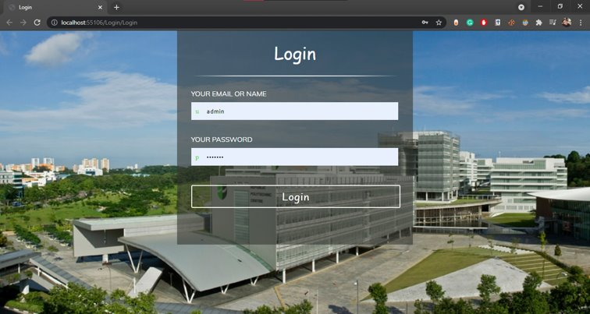

**After Login, you will be redirected to the Main Page**

At the main page, you will be able to see a list of vehicles to view

From the page, you will be able to click on either "Edit" or "Delete" on the "Action" column

You can also click on the "Add Vehicle" or "Carparks" on the Navigation Bar

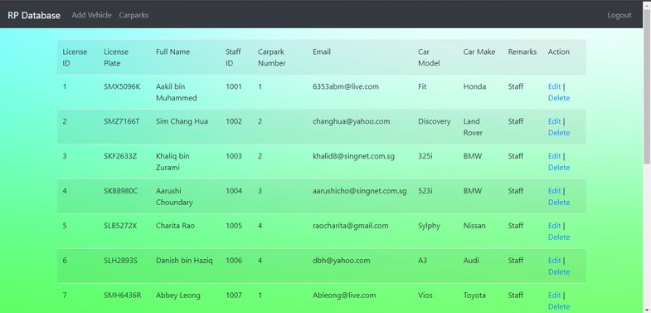

**After clicking on "Add Vehicle", you will be redirected to this page**

On the page, just enter the details as follow from the label.

E.g.

License ID: 16

License Plate: SJE1667A

Full Name: Syah Bin Muhammed

Staff ID: 1016

Carpark No: 4

Email: [syah@gmail.com](mailto:syah@gmail.com)

Car Model: Estima

Car Make: Toyota

Remarks: st@ff

After entering the details, click on the "Add Vehicle" button at the bottom

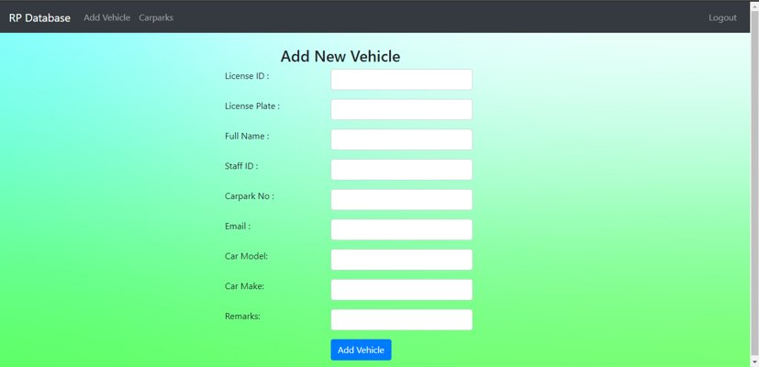

You will then be redirected to the main page where you can view your added vehicles.

A "Vehicle Added" pop up will be shown once your vehicle is added.

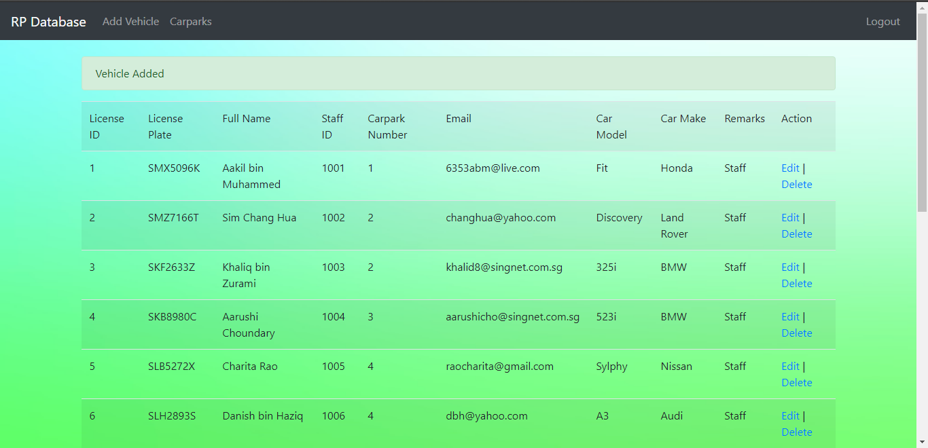

**After clicking on "Edit", you will be redirected to this page**

You will be able to edit the fields that you would like to edit.

After changing the fields, click on the "Update" button below

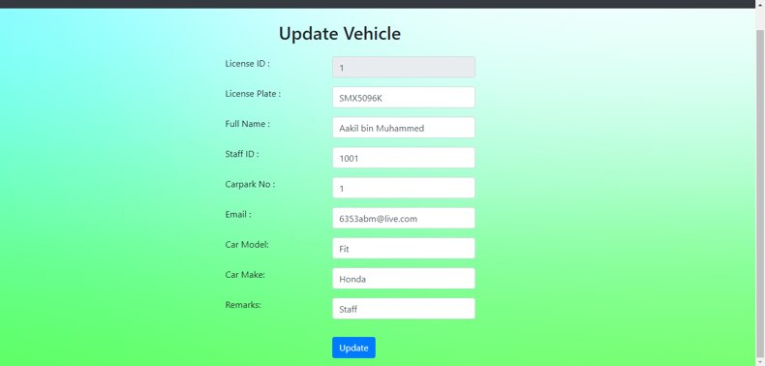

You will then be redirected to the main page where you can view your edited vehicles.

A "Vehicle Updated" pop up will be shown once your vehicle is updated.

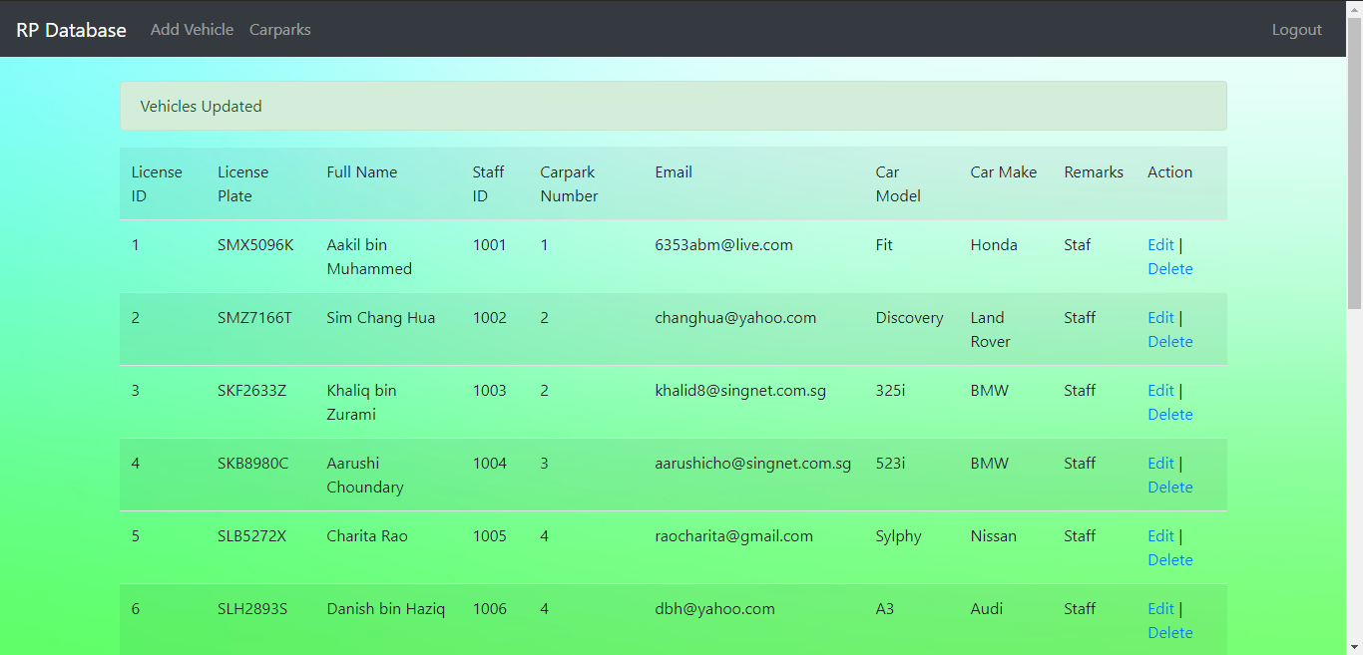

**After clicking on "Delete", a "Vehicle Deleted" pop up will be shown**

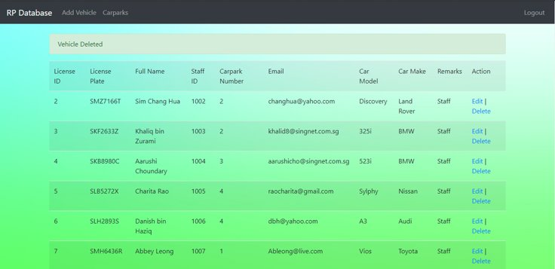

**Additional Notes**

***After clicking on "Carparks" you will be redirected to this page***

This page will be a referral for the different Carpark Number 1 to 4.

Where

Carpark Number:

1. Open Carpark
2. Staff Carpark
3. Multi-Storey Carpark
4. Campus Heights Carpark

